1. Install the Selenium IDE extension in your Chrome or Firefox browser and confirm it appears in your browser toolbar.
Ans=>
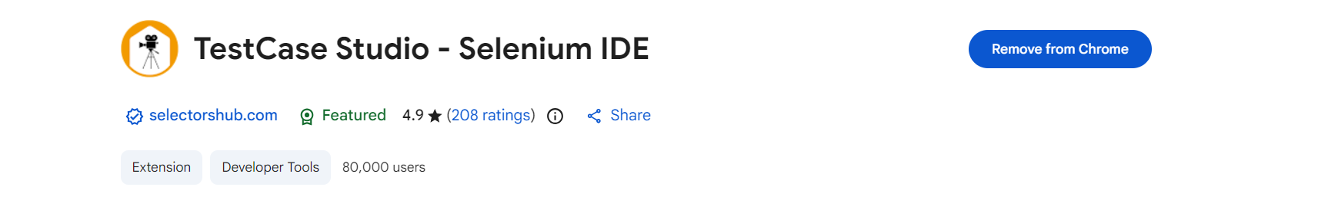

2. Use Selenium IDE to record a test case that opens the Flipkart homepage, searches for 'headphones', and clicks on the first product link.
Ans=> 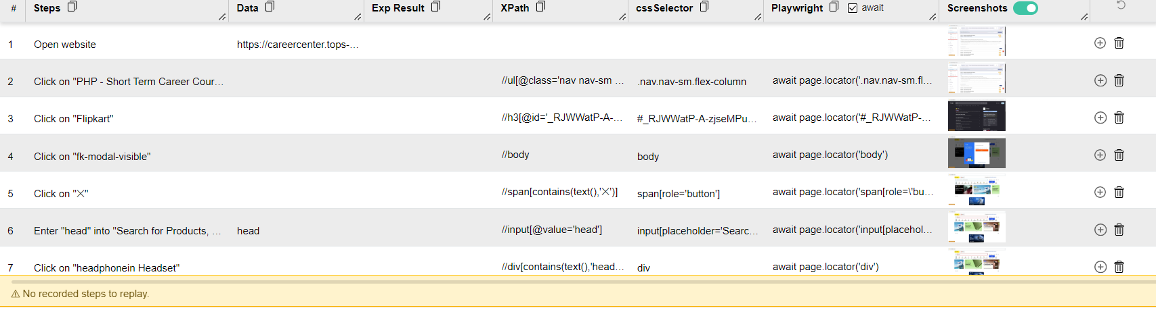

3. With Selenium IDE, record a test that logs into Instagram's web login page using any dummy credentials and verifies that an error message appears.<br><br><em><strong>Hint:</strong> Look for a 'verify text' or 'assert' command to check for the error.</em>
Ans=>
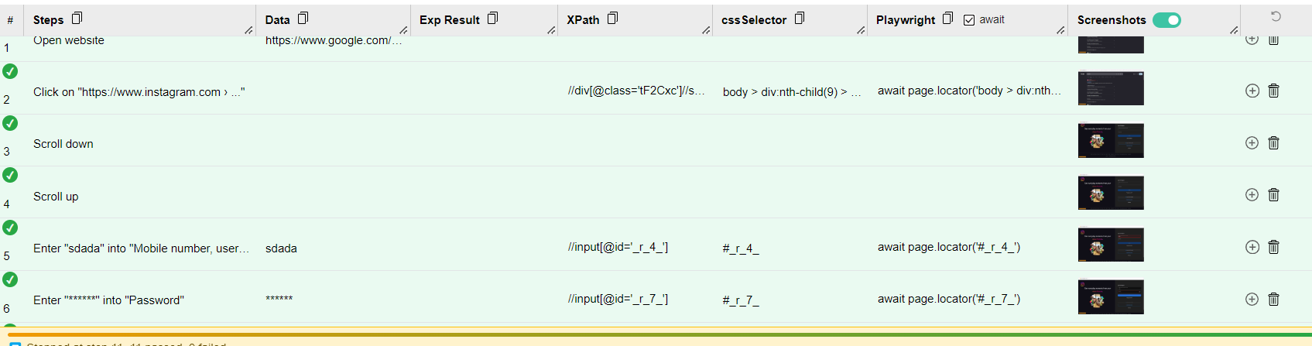

4. Install Katalon Recorder and record a test that opens Zomato, enters 'pizza' in the search bar, and captures a screenshot after the results load.<br><br><em><strong>Constraint:</strong> Use the screenshot command provided by the tool.</em>
Ans=>
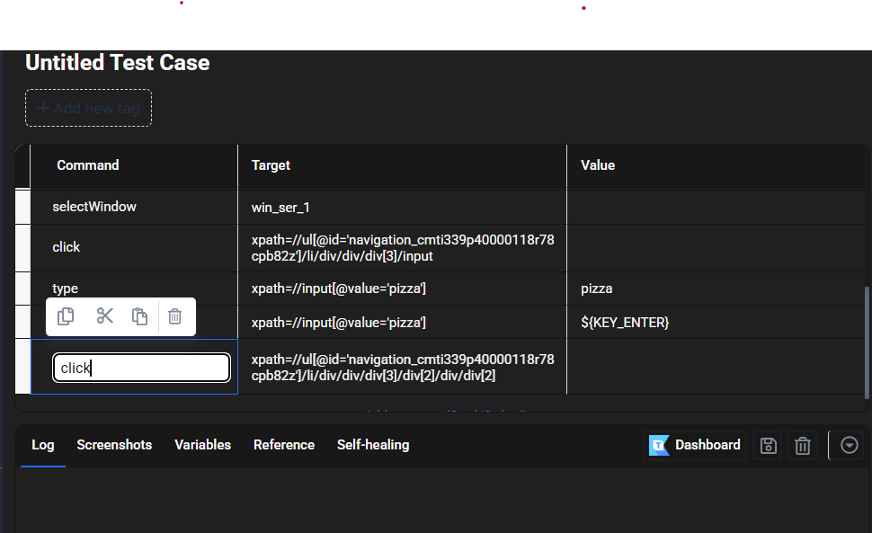
5. List 3 types of website tasks that non-programmers can automate using Selenium IDE or Katalon Recorder, and for each, briefly explain one limitation they might face with no-code automation.
- Ans=> Form filling and submission — Automate entering data into web forms, selecting options, and clicking Submit.
Limitation: Dynamic fields or CAPTCHAs can break the recorded workflow.
- Website testing/regression checks — Automate actions such as logging in, navigating pages, and verifying that buttons or links work.
Limitation: Complex, highly dynamic pages may require custom code when recorded steps become unreliable.
- Data collection/scraping — Automate visiting pages and extracting visible information such as product names or prices.
Limitation: No-code tools can struggle with pagination, infinite scrolling, or content loaded asynchronously.

